

**INTERNSHIP PROJECT**

**Under the guidance of:**

Pargol Poshtareh

Asen Grozdanov

Lucas Branctella



**Group Members:**

Darshan Kikani(2091225)

Harsh Patel(2091145)

Diksha Chawla(2091182)

Gurpreet Singh(2091193)

Jayankumar Patel(2091348)

Japdeep Singh(2091308)

**Table of Content**

**1) Introduction** **3**

**1.1) Objective** **3**

**1.2) Scope** **3**

**1.2.1) Scope for customers**  **3**

**1.2.2) Scope for admin**  **4**

**1.3) Purpose** **4**

**1.4) Technology Used** **4**

**2) Backlog** **5**

**2.1) User Story** **5**

**2.2) Release Plan** **11**

**3) Specific Requirements** **15**

**3.1) Functional Requirements** **15**

**3.2) Non-Functional Requirements** **18**

**4) Prototype** **20**

# 

# 

# 1) Introduction

Nowadays it’s a hassle to go for shopping and to roam around at the supermarket and look for the product that people want to purchase. People do not like to spend their time standing in lines for shopping or for billing. The online grocery system will minimize all the customer efforts and time and will minimize roaming at stores. In addition, the website will be fully computerized, easy to use, time saving and well organized. It will allow administration to keep the track of orders of customers.

## 1.1) Objective

The main objective for our team is to produce a fully functional website by the end of the final iteration . Website will reduce the efforts for the customer as well as the owner. Another objective of the project is to test every module of the website by the end of final iteration before handing it to the client. This website would eliminate various constraints faced by customers and owners.

## 1.2) Scope

### 1.2.1) Scope for customers :

* Customers can place orders from anywhere at any time.
* Customers can keep records of past orders.
* Customers don’t have to visit shop.
* Customers have the option to pay online.
* Customers can get their products at doorstep.
* Customers can search for their products very easily instead of roaming in stores.
* Customers can also print their invoice.

### 1.2.2) Scope for admin :

* Admin can add/update/delete product detail and price.
* Admin can update/remove the account of customers.

## 

## 1.3) Purpose

Main reason for developing this website is to reduce the problems for customers in shopping for groceries from the store. Second reason is that customers don’t have to spend more time travelling to stores, so they can utilize their precious time in other activities. It will also help to reduce the overall expenses of the shopkeeper. Customers who are living far from the shop can also order groceries and the shopkeeper would have more sales.

## 1.4) Technology Used

Programming Language : Php , Java script, Html, css

Database : Mysql

Tool : WAMP/XAMPP, Sublime Editor, Bootstrap

Prototype tool: Justinmind

# 2) Backlog

## 2.1) User Story:

| Story Id | User Story Description | Use Story Points | Priority |
| --- | --- | --- | --- |
| S001 | As user should be able to land on the home page | 8 | MEDIUM |
| S002 | As a user I should be able to sign up to the website | 13 | HIGH |
| S003 | As a user I should be able to log in to a website using email id and password | 8 | HIGH |
| S004 | As a user I should be able to see and select the category of grocery | 13 | MEDIUM |
| S005 | As a user I should be able to land on the page of each category of grocery | 8 | MEDIUM |
| S006 | As a user I should be able to reset Password | 13 | HIGH |
| S007 | As a user I should be able to add product into the cart | 8 | MEDIUM |
| S008 | As a user I should be able to alter the quantity of the product | 13 | HIGH |
| S009 | As a user able to view the Cart | 13 | MEDIUM |
| S010 | As a user I should be able to see the total price of a cart after removing/adding the item | 13 | HIGH |
| S011 | As a user I should be able to enter my Full Name, Address, email id and mobile phone number for billing and shipping details | 13 | HIGH |
| S012 | As a user I should be able to generate the invoice for the Products/Items | 8 | MEDIUM |
| S013 | As a user I should be able to Make payment | 13 | HIGH |
| S014 | As a user I should be able to see and update my profile | 13 | HIGH |
| S015 | As a user I should be able to log out | 8 | HIGH |
| S016 | As a user I should be able to search for the product using search bar | 13 | LOW |
| S017 | As a user I should be able to add item to the Wishlist. | 13 | LOW |
| S018 | As an admin I should be able to login to the admin page | 8 | HIGH |
| S019 | As an admin I should be able to add/remove/update items to the website | 13 | HIGH |
| S020 | As an admin I should be able to print the past receipts of the customers. | 13 | HIGH |
| S021 | As an admin I should be able to remove the users | 5 | HIGH |
| Total User Story Points: 230 | | | |

## 2.2) Release Plan:

| Release No | Deliverables | Release Date |
| --- | --- | --- |
| 1. | S001: As user should be able to land on the home page    S002: As a user I should be able to sign up to the website    S003: As a user I should be able to log in to a website using email id and password    S004: As a user I should be able to see and select the category of grocery    S005: As a user I should be able to land on the page of each category of grocery    S006: As a user I should be able to reset Password      S007: As a user I should be able to add product into the cart      S015: As a user able to log out      Total user story points covered: 79 |  |
| 2. | S008: As a user I should be able to alter the quantity of the product    S009: As a user able to view the Cart      S010: As a user I should be able to see the total price of a cart after removing/adding the item    S011: As a user I should be able to enter my Full Name, Address, email id and mobile phone number for billing and shipping details    S013: As a user I should be able to Make payment    S014: As a user I should be able to see and update my profile      Total user story points covered: 78 |  |
| 3. | S012: As a user I should be able to generate the invoice for the Products/Items.    S016: As a user I should be able to search for the product using search bar    S017: As a user I should be able to add item to the Wishlist.    S018: As an admin I should be able to login to the admin page    S019: A As an admin I should be able to add/remove/update items to the website    S020: As an admin I should be able to print the past receipts of the customers.    S021: As an admin I should be able to remove the users      Total user story points covered: 73 |  |

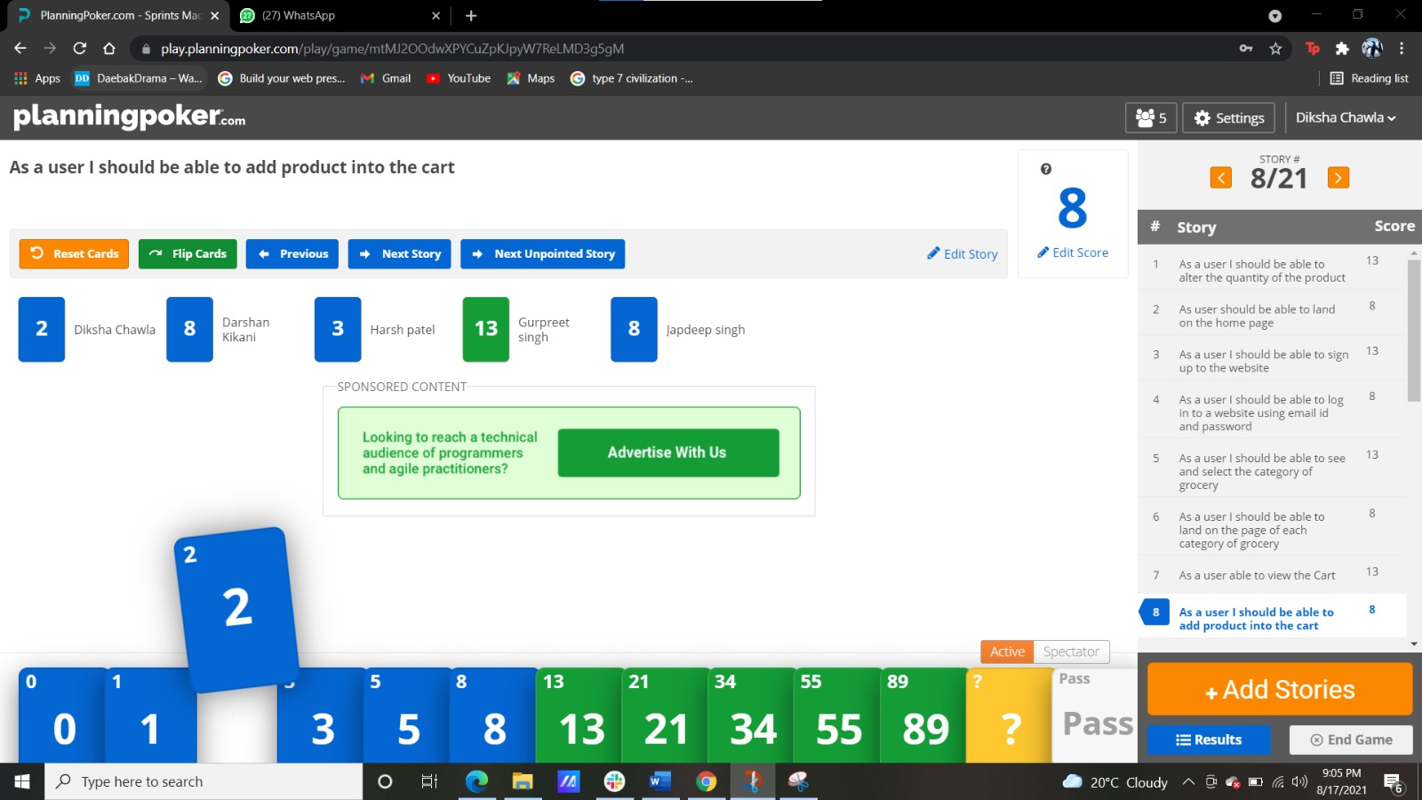

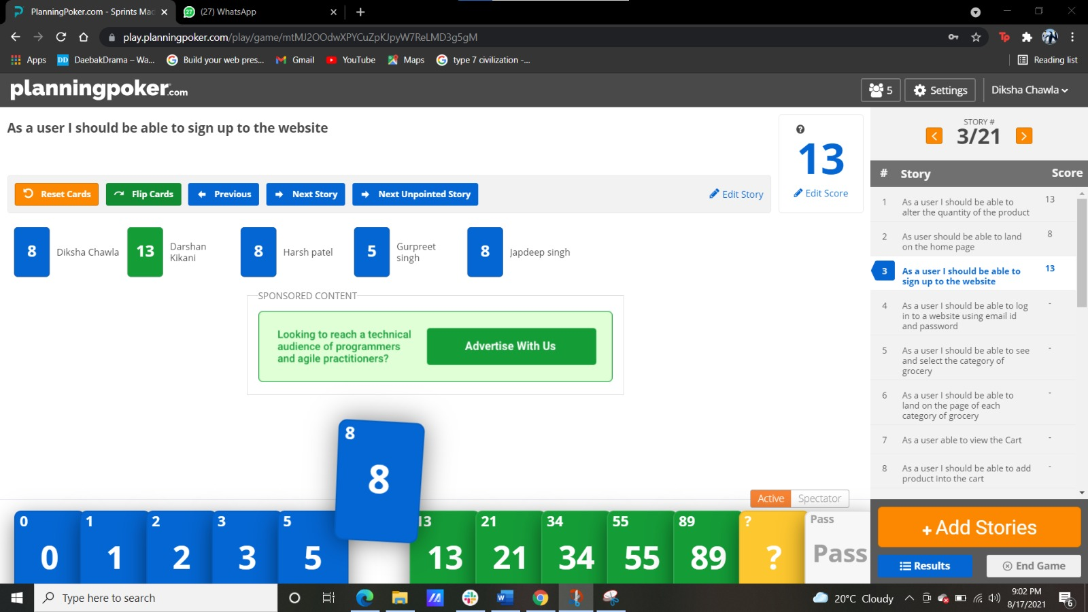

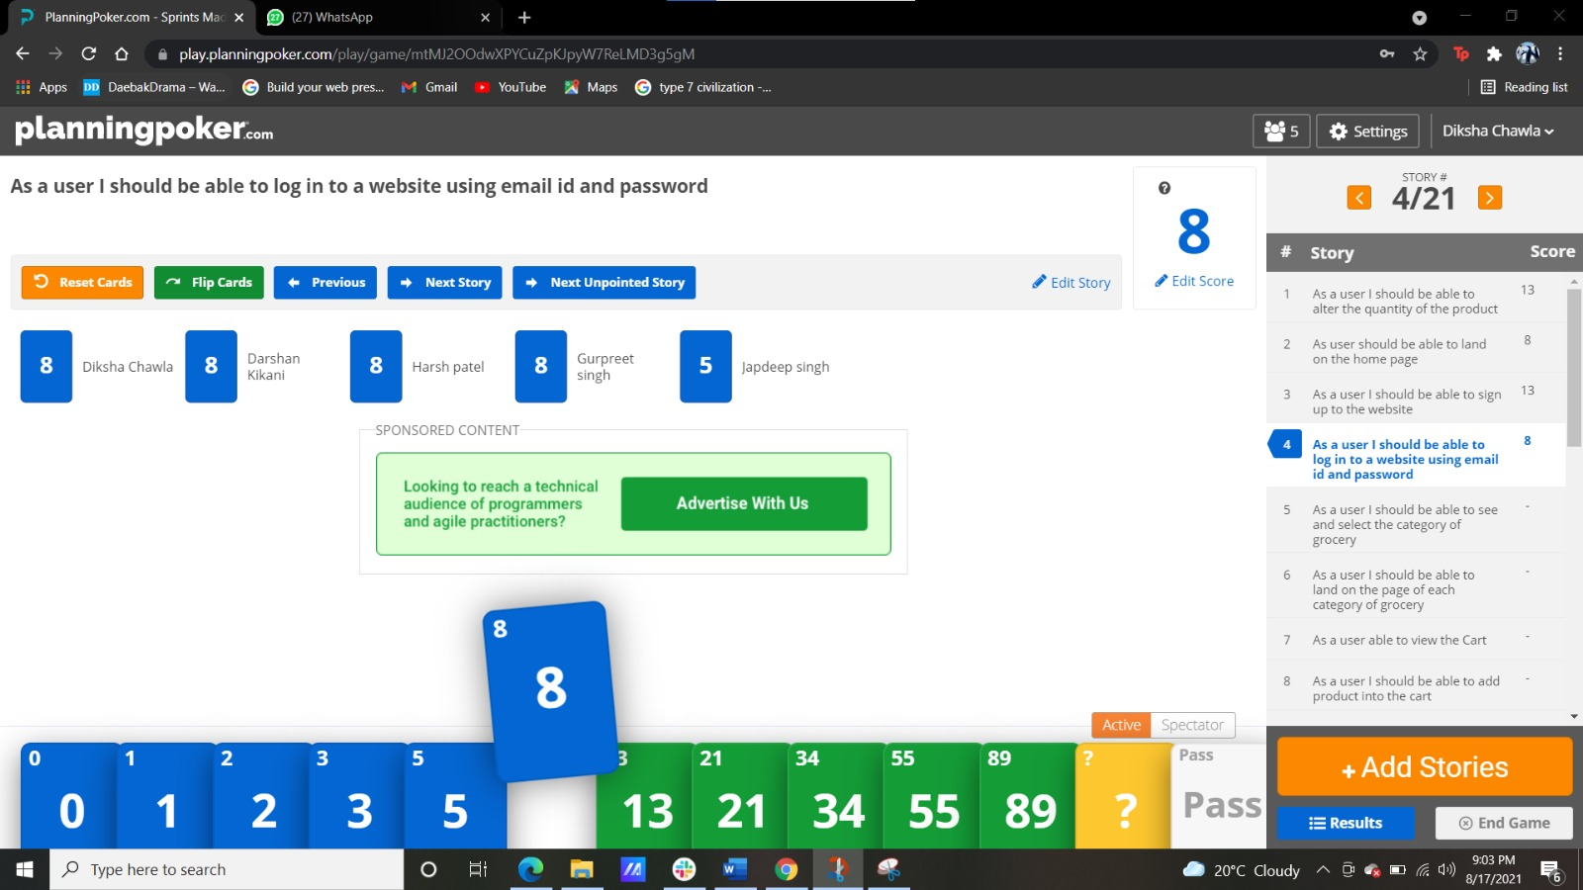

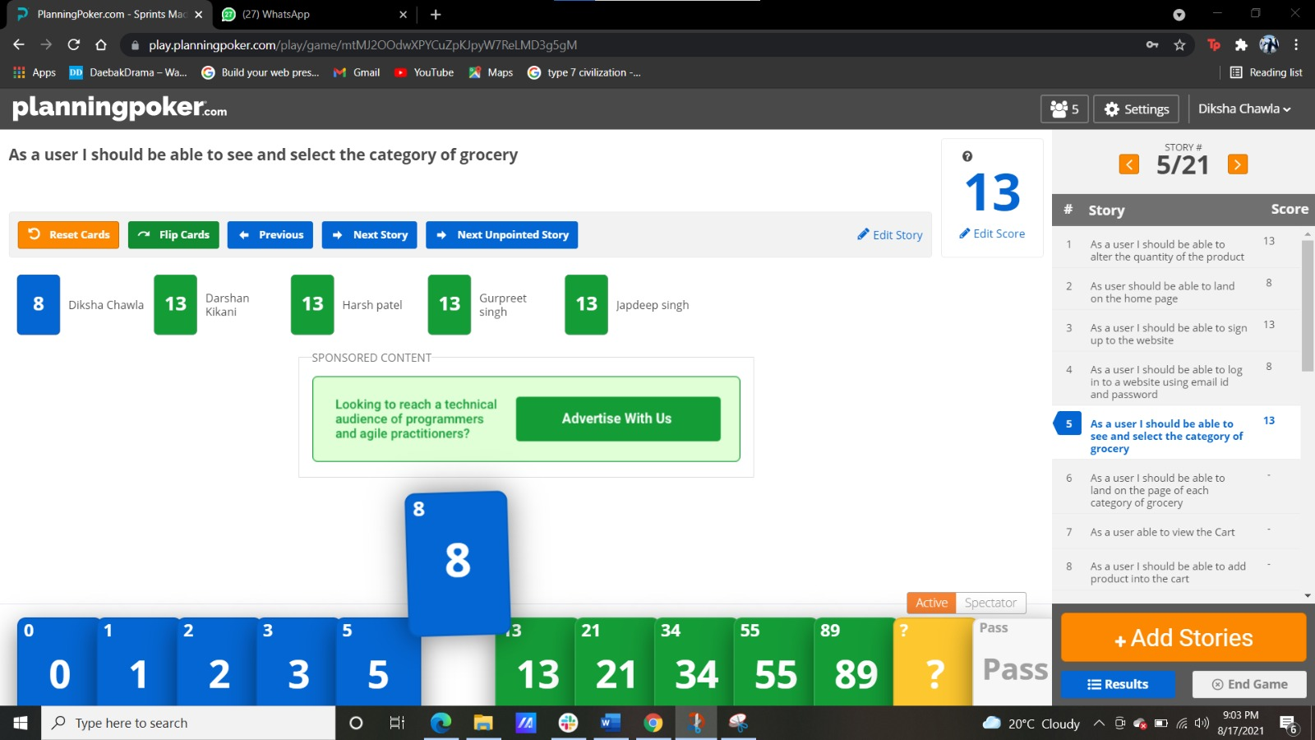

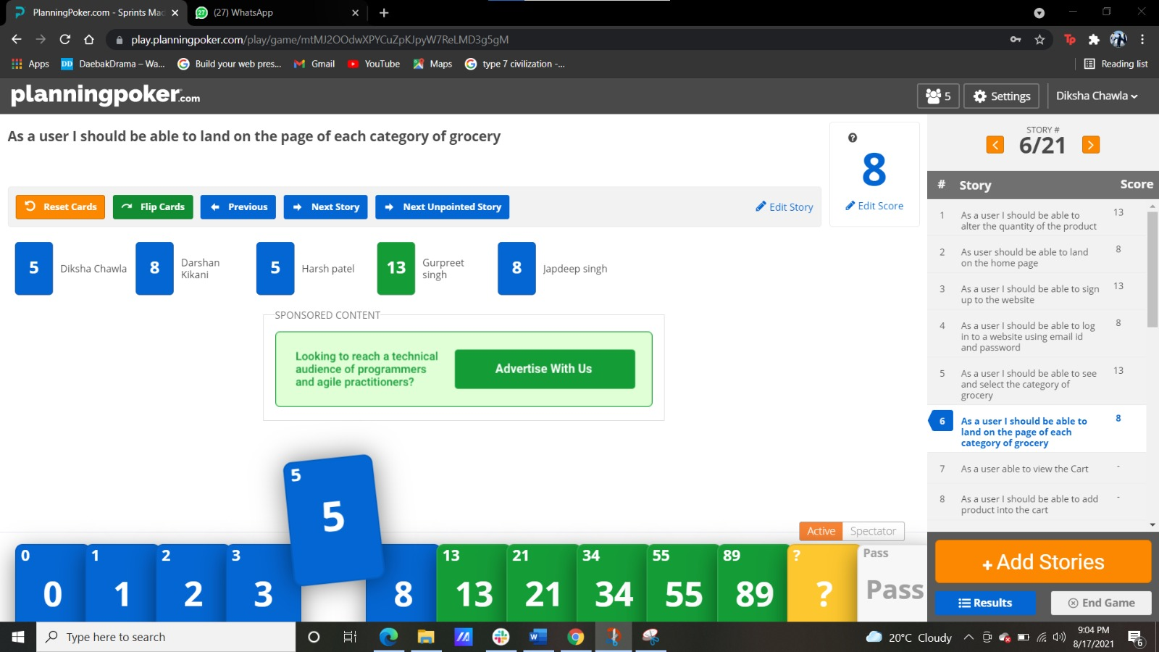

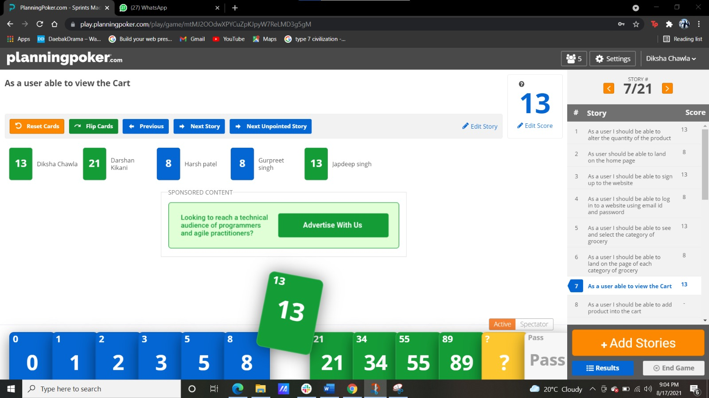

# 3) Specific Requirements

## 3.1) Functional Requirements

In software engineering, a functional requirement defines a system or its components. It describes the functions a software must perform. A function is nothing but inputs, its behavior, and outputs.

| Requirement ID | Requirement Statement | Comments |
| --- | --- | --- |
| FR001 | Login/Signup | The website must have a login and signup functionality for users to register and access the website. |
| FR002 | Password Reset | The website must have a procedure to reset the password for the registered user if the user forgets. |
| FR003 | Search Product | The registered user should be able to search for item on website using search bar functionality |
| FR004 | Profile Update | The registered user must be able to update the profile information for themselves. |
| FR005 | Add/Update/View item on Cart | The registered user should be able to add items, update items on the cart. Users should also be able to view the cart. |
| FR006 | Add/Update/View item on Wishlist | The registered user should be able to add items, update items on the wishlist. Users should also be able to view the wishlist. |
| FR007 | Make Payment | The website should have functionality for users to make payment. |
| FR008 | Generate Invoice | The website must have functionality to generate invoices for users. |
| FR009 | Logout | The website should have functionality to allow users to logout from the website. |
| FR010 | Update Product Information (Admin) | The website should have functionality to allow admin to add/remove/update product on the website from admin’s end |
| FR011 | Remove user (Admin) | The website should have functionality to allow admin to remove user profile from the website from admin’s end |
| FR012 | Access Past Receipts (Admin) | The website should have functionality to allow admin to access past receipts of customers from admin’s end |

## 3.2) Non-Functional Requirements

A non-functional requirement defines the quality attribute of a software system. They represent a set of standards used to judge the specific operation of a system. Example, how fast does the website load?

| Requirement ID | Requirement Statement | Comments |
| --- | --- | --- |
| NFR001 | Login authentication | The website must provide login only to the users are authentically registered. |
| NFR002 | Performance and response time | The performance of the website must be effective for more than 50 users at one time with fast response time. |
| NFR003 | Platform independent | Website must work with various platforms, like firefox, chrome, operamini etc |
| NFR004 | Usability | Website UI must be effective, efficient, easy to learn so even first time users are able use it easily |
| NFR005 | Hardware compatibility | Website must work on all the devices, like laptop, mobile phone, PC etc. |
| NFR006 | Maintainability | Website must be easy to maintain as a result of lesser complex code. |
| NFR007 | Security | Website must be secure as data must be saved on DBMS and should be accessible by just admin. |
| NFR008 | Interoperability | Website must be able to operate smoothly in conjunction to other websites working on the same platform. |
| NFR009 | Robustness | Website must deal with invalid or erroneous inputs effectively, for example: incorrect password/emailid. |
| NFR010 | Availability | The website must be available to access all times of the day. |

# 4) Prototype

Home

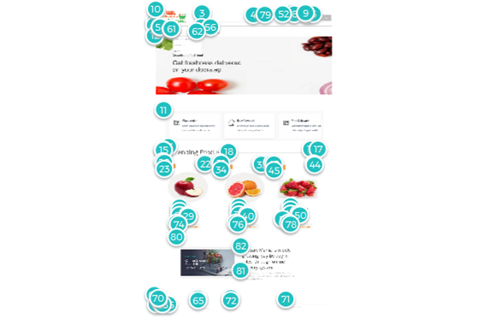

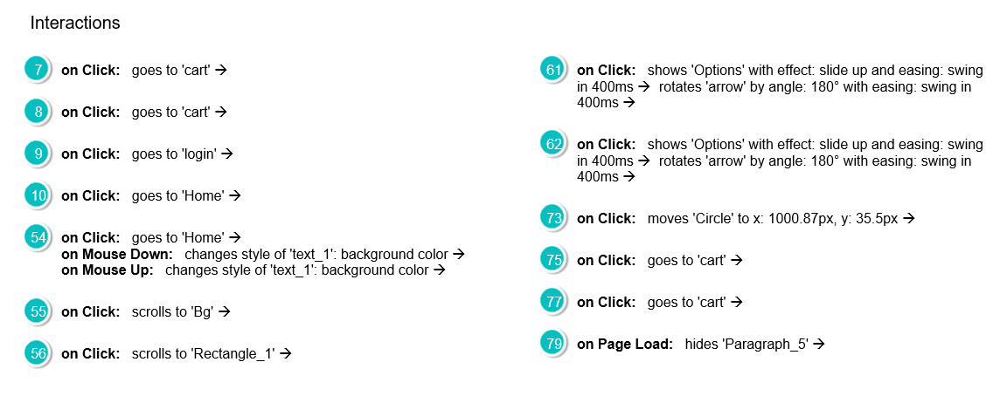

Home login

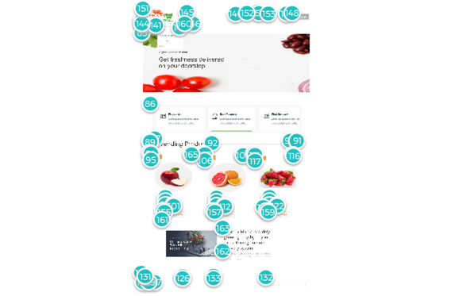

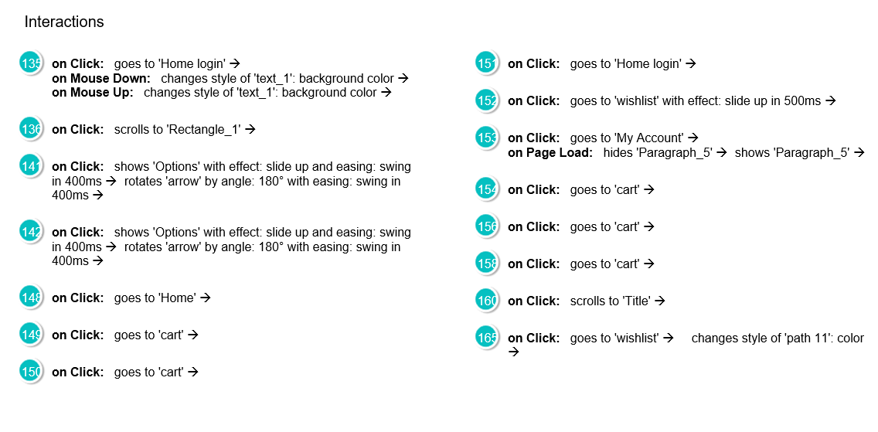

Login

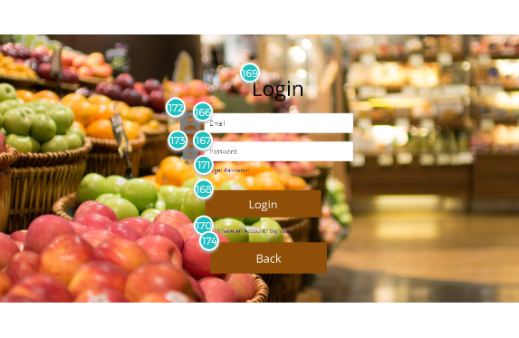

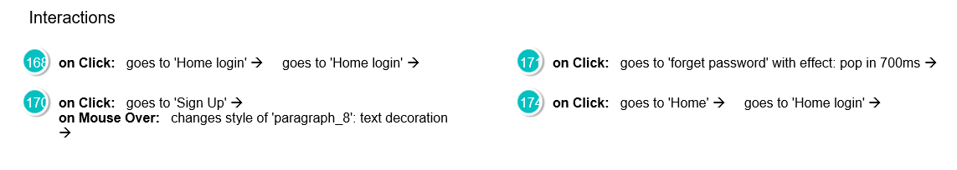

Sign Up

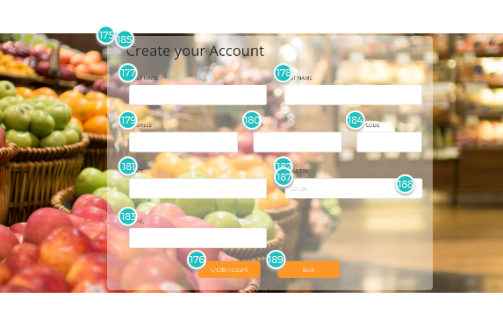

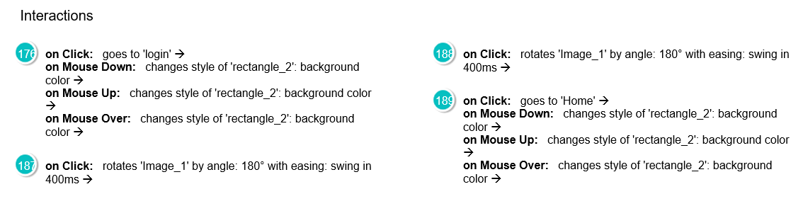

Dairy Products

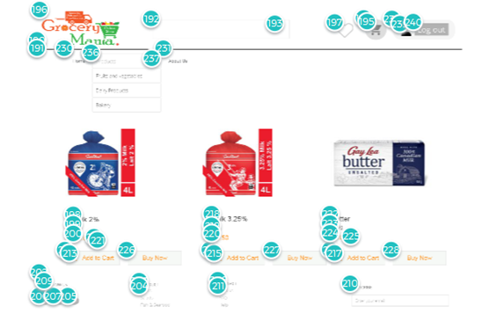

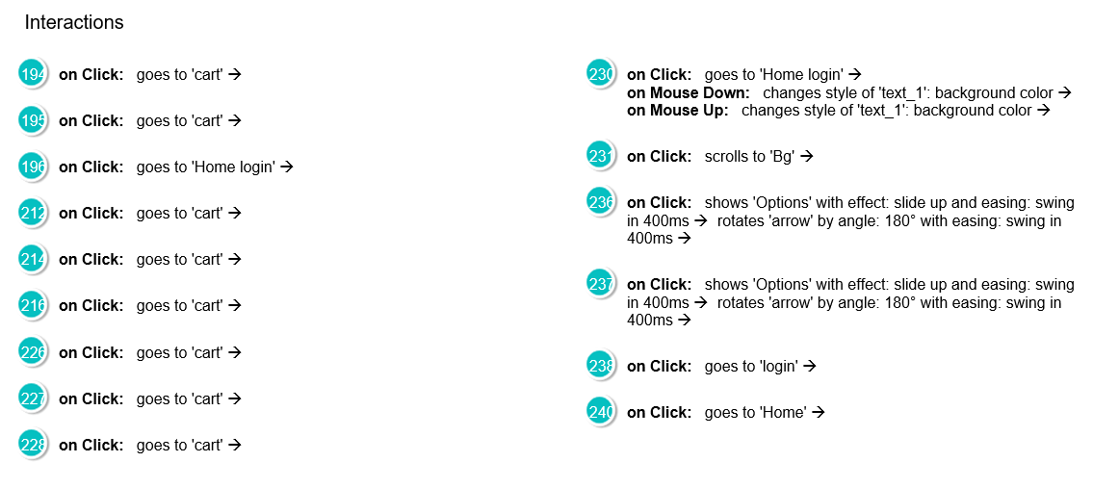

Bakery

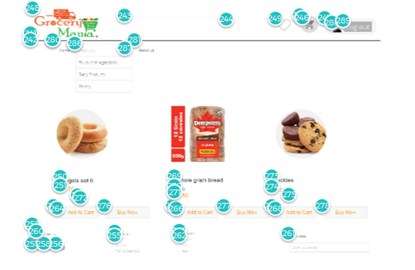

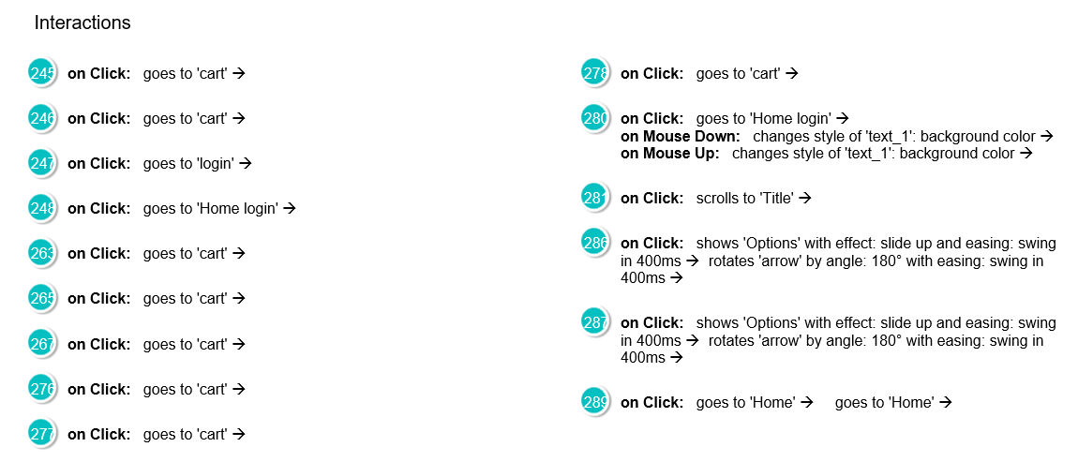

Fruits and Vegetables

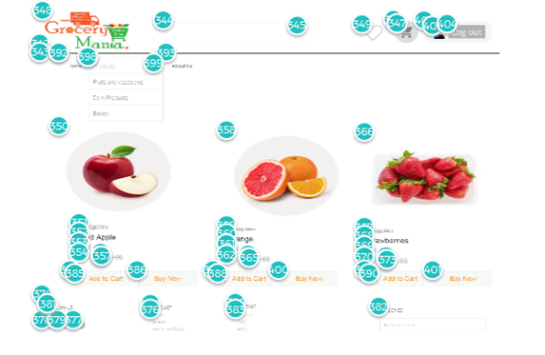

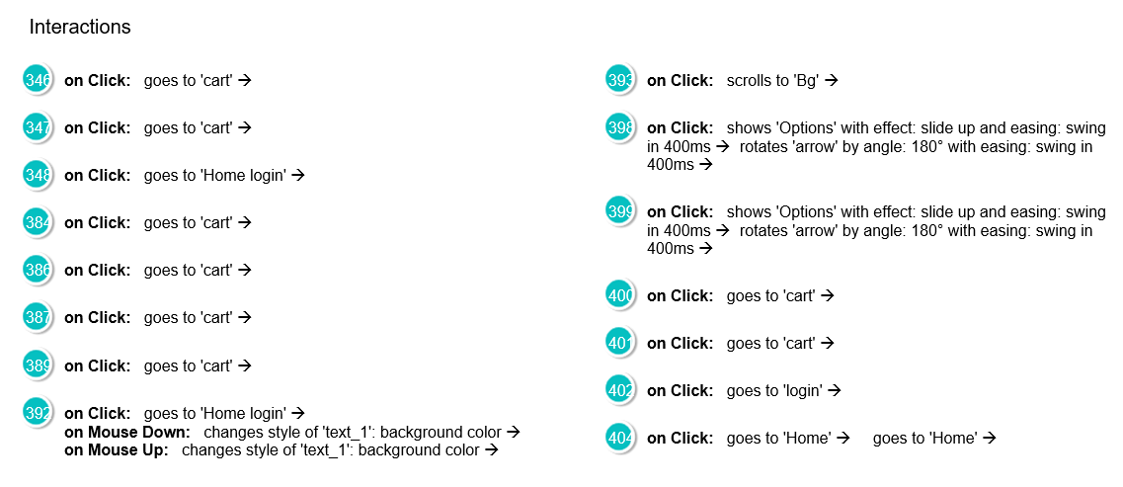

Billing

|  |
| --- |



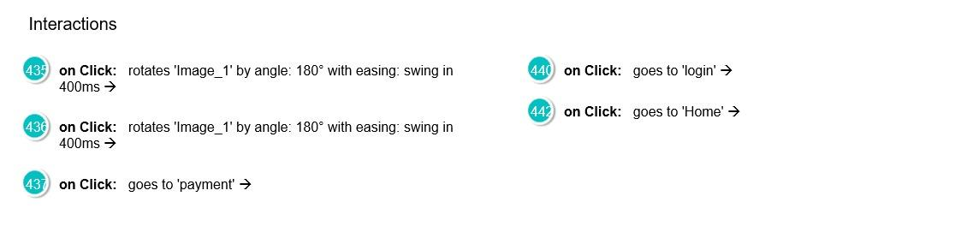

Payment

|  |
| --- |



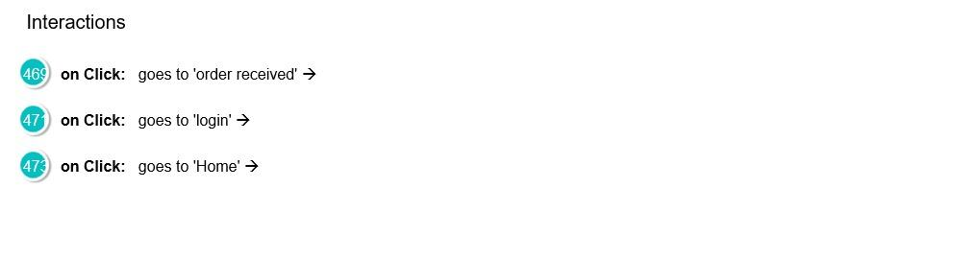

Order received

|  |
| --- |



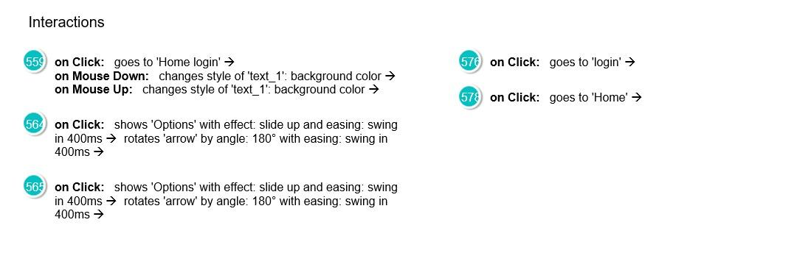

Forget Password

|  |
| --- |





My Account

|  |
| --- |



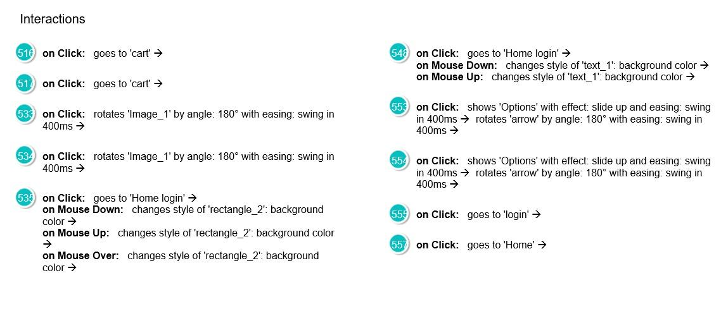

Wishlist

|  |
| --- |



